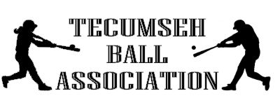
T-Ball, Coach Pitch, Softball and Baseball

Registration will be held on:

Wednesday, February 26th, 2020; From 4-6 pm
At the American National Bank,
President’s Room, 310 Broadway,
Tecumseh, NE

If unable to attend:
Forms & payments can be turned in to the front desk at the Johnson County Sherriff’s Office 24/7 or to the Elementary Office at JCC. Due to League entry qualifications NO ENTRIES WILL BE ACCEPTED AFTER MARCH 13th!!

